Implementation of a Rule-Based Expert System for Student Academic Performance Prediction
Azam Azri Ahmad
Department of Electrical and Information Engineering
Faculty of Engineering, Universitas Gadjah Mada
Yogyakarta, Indonesia
azamazriahmad@mail.ugm.ac.id

Abstract— Predicting student academic performance is essential for early academic intervention and educational decision support. While machine learning approaches dominate recent research, they often suffer from limited interpretability and high data dependency. This paper presents the implementation and evaluation of a Rule-Based Expert System (RBES) using forward chaining to classify student performance into low, medium, and high categories. The system is implemented on the Student Alcohol Consumption dataset and relies exclusively on expert-defined rules derived from educational domain knowledge. Experimental results demonstrate that the RBES achieves interpretable predictions with transparent reasoning, albeit with moderate accuracy. The findings confirm the suitability of rule-based systems as explainable baseline solutions for educational analytics.
Keyword— Rule-Based Expert System, Student Performance Prediction, Forward Chaining, Educational Decision Support

INTRODUCTION
Student academic performance prediction has become a central topic in educational data analysis due to its role in identifying students at risk and supporting timely interventions. Most contemporary studies emphasize machine learning and hybrid approaches to maximize predictive accuracy [1]. However, these data-driven models are frequently criticized for their black-box behavior and limited explainability, which restricts their adoption in educational decision-making contexts.
Rule-Based Expert Systems (RBES) offer an alternative paradigm by encoding human expertise into explicit IF–THEN rules. Unlike statistical models, RBES do not require training phases and instead rely on deterministic inference mechanisms. Prior studies have shown that expert systems remain relevant in domains where interpretability, auditability, and knowledge transparency are essential [2],[7].
This study focuses strictly on the implementation of a rule-based expert system, without integrating machine learning, feature learning, or optimization algorithms. The objective is to evaluate how well an RBES can approximate student performance classification using domain-inspired rules, and to analyze its strengths and limitations through quantitative evaluation.

RELATED WORK
Research on student performance prediction has predominantly evolved toward machine learning-based methods, including decision trees, neural networks, and ensemble techniques [1]. While these approaches often achieve high predictive accuracy, they require large labeled datasets and provide limited interpretability.

Several studies have emphasized the importance of explainable and knowledge-driven models. Belief Rule Base (BRB) systems have been proposed to manage uncertainty while preserving interpretability [6]. Hybrid expert systems combining forward chaining with weighting mechanisms have demonstrated strong transparency in academic stress diagnosis and educational decision support [7].
Surveys in educational data mining highlight that no single predictive approach is universally superior and that simpler, interpretable systems remain valuable as baseline or complementary solutions [1], [5]. This work aligns with such perspectives by implementing a pure RBES, positioning it as an explainable reference model rather than a competitor to machine learning-based predictors.

METHODOLOGY
The proposed system is a Rule-Based Expert System using forward chaining inference, designed to classify student academic performance into three categories: low, medium, and high.

Dataset and Ground Truth
The system uses the Student Alcohol Consumption dataset, consisting of 395 student records with 33 attributes. The ground truth performance label is derived from the final grade (G3) using expert-defined thresholds:
Low: G3 ≤ 10
Medium: 11 ≤ G3 ≤ 14
High: G3 ≥ 15
This discretization mirrors common educational assessment practices and avoids probabilistic labeling..

Rule Base Design
A total of 20 expert rules were manually defined based on educational reasoning. Each rule consists of antecedents involving study time, failures, absences, parental education, family support, and lifestyle indicators. Rules are annotated with priority levels and certainty factors (CF) to support conflict resolution.
Rules are grouped into three categories corresponding to performance levels. The rule base is stored in JSON format to ensure modularity and auditability.

Inference Engine
The inference mechanism applies forward chaining, starting from observed student attributes and matching them against rule antecedents. When multiple rules are activated, conflicts are resolved based on priority, rule specificity, and recency. Certainty factors are aggregated using a conservative maximum strategy, consistent with expert system design principles [7].
No learning or parameter tuning is performed, ensuring that the system remains fully rule-driven.

Evaluation Metrics
System performance is evaluated using accuracy, precision, recall, F1-score, and confusion matrix analysis. Unmatched cases (no rule fired) are excluded from metric computation to preserve the deterministic nature of expert systems.

RESULT AND ANALYSIS
The RBES successfully generated predictions for 83.3% of cases, while 16.7% remained unclassified due to insufficient rule coverage. This behavior is inherent to rule-based systems and reflects the trade-off between precision and coverage.

Confusion Matrix Analysis
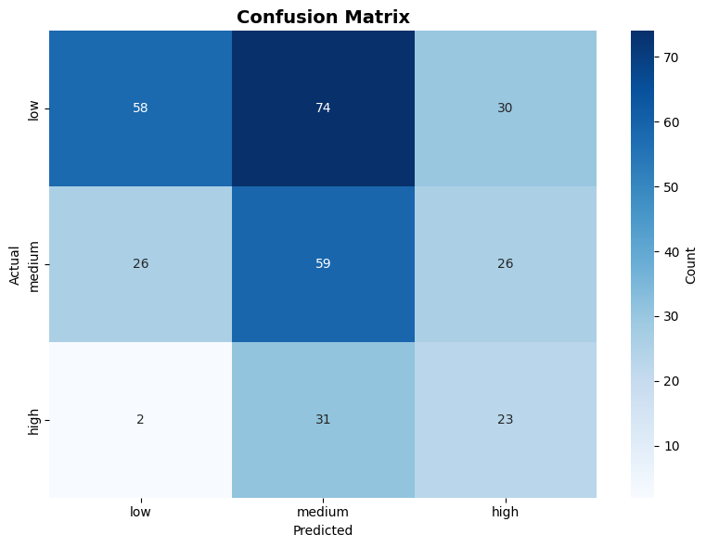
Fig 1. Confusion Metric Performance
Figure 1 illustrates the confusion matrix of predicted versus actual performance classes. The matrix shows a strong tendency toward medium-level predictions, indicating conservative rule design. Misclassifications primarily occur between adjacent classes (low–medium and medium–high), while severe misclassification (low predicted as high) is minimal.
Rules are grouped into three categories corresponding to performance levels. The rule base is stored in JSON format to ensure modularity and auditability.

Performance Metrics
Table I summarizes the per-class evaluation metrics.
TABEL I. PERFORMANCE METRICS BY CLASS
Class | Precision | Recall | F1-Score
Low | 0.674 | 0.358 | 0.468
Medium | 0.36 | 0.532 | 0.429
High | 0.291 | 0.411 | 0.341

The results indicate that the RBES favors interpretability over predictive accuracy. Medium performance recall is comparatively higher, reflecting rule generalization. High performance precision remains low due to strict rule constraints..

Interpretability and Explanation
One of the main strengths of the RBES lies in its ability to generate human-readable explanations. Each prediction is accompanied by fired rule identifiers and condition traces, enabling transparent academic reasoning. This aligns with findings in explainable AI and expert system literature [3],[7].

CONCLUSION
This study demonstrates the practical implementation of a Rule-Based Expert System for student academic performance prediction. While the system does not achieve high predictive accuracy compared to machine learning models, it provides transparent, auditable, and interpretable decision-making.
The results confirm that RBES remains a viable baseline approach in educational analytics, particularly in scenarios where explainability and expert trust are prioritized. Future work may explore controlled hybridization while preserving rule interpretability, but such extensions are beyond the scope of this implementation-focused study.

VIDEO DEMONSTRATION
To complement the experimental evaluation, a video demonstration is provided to visually illustrate the implementation and operational workflow of the proposed Rule-Based Expert System. The demonstration video is publicly accessible at https://youtu.be/kpADR1xV-_Y

References
- J. Oktavianto, D. Sulisworo, and W. Wahyuni, "Hybrid Expert System for Academic Stress Diagnosis Using Forward Chaining and Score Weighting," Journal of Educational Technology and Innovation, 2023.​
- A. Winarko, A. B. Mutiara, and H. S. Tambunan, "Advancing Educational Data Mining for Enhanced Student Performance Prediction: A Fusion of Feature Selection Algorithms and Classification Techniques with Dynamic Feature Ensemble Evolution," International Journal of Advanced Computer Science and Applications, vol. 14, no. 8, 2023.​
- H. Waheed, S. Hassan, N. Aljohani, J. Hardman, S. Alelyani, and R. Nawaz, "Academic Performance Prediction Using Machine Learning Approaches: A Survey," International Journal of Educational Technology in Higher Education, vol. 17, article 43, 2020.​
- A. Sulub, A. Alshareef, S. Karabatis, and A. Elmongui, "Explainable AI Framework for Predicting Student Academic Success Through Personality Analysis," IEEE Access, 2024.​
- W. Gonzales, Z. Cordero, C. D. Abanto-Ramírez, E. T. Susanibar Ramírez, H. Iftikhar, and J. L. López-Gonzales, "A Hybrid AI Approach for Predicting Academic Performance in RBE Students," Frontiers in Artificial Intelligence, vol. 8, article 1651100, October 2025.​
- X. Wang, Y. Zhao, C. Li, and P. Ren, "ProbSAP: A Comprehensive and High-Performance System for Student Academic Performance Prediction," Pattern Recognition, vol. 137, article 109309, 2023.​
- P. Wu, L. Liu, Z. Huang, and J. B. Yang, "A Student Academic Performance Prediction Model Based on the Interval Belief Rule Base," Expert Systems with Applications, vol. 213, article 118927, 2023.

